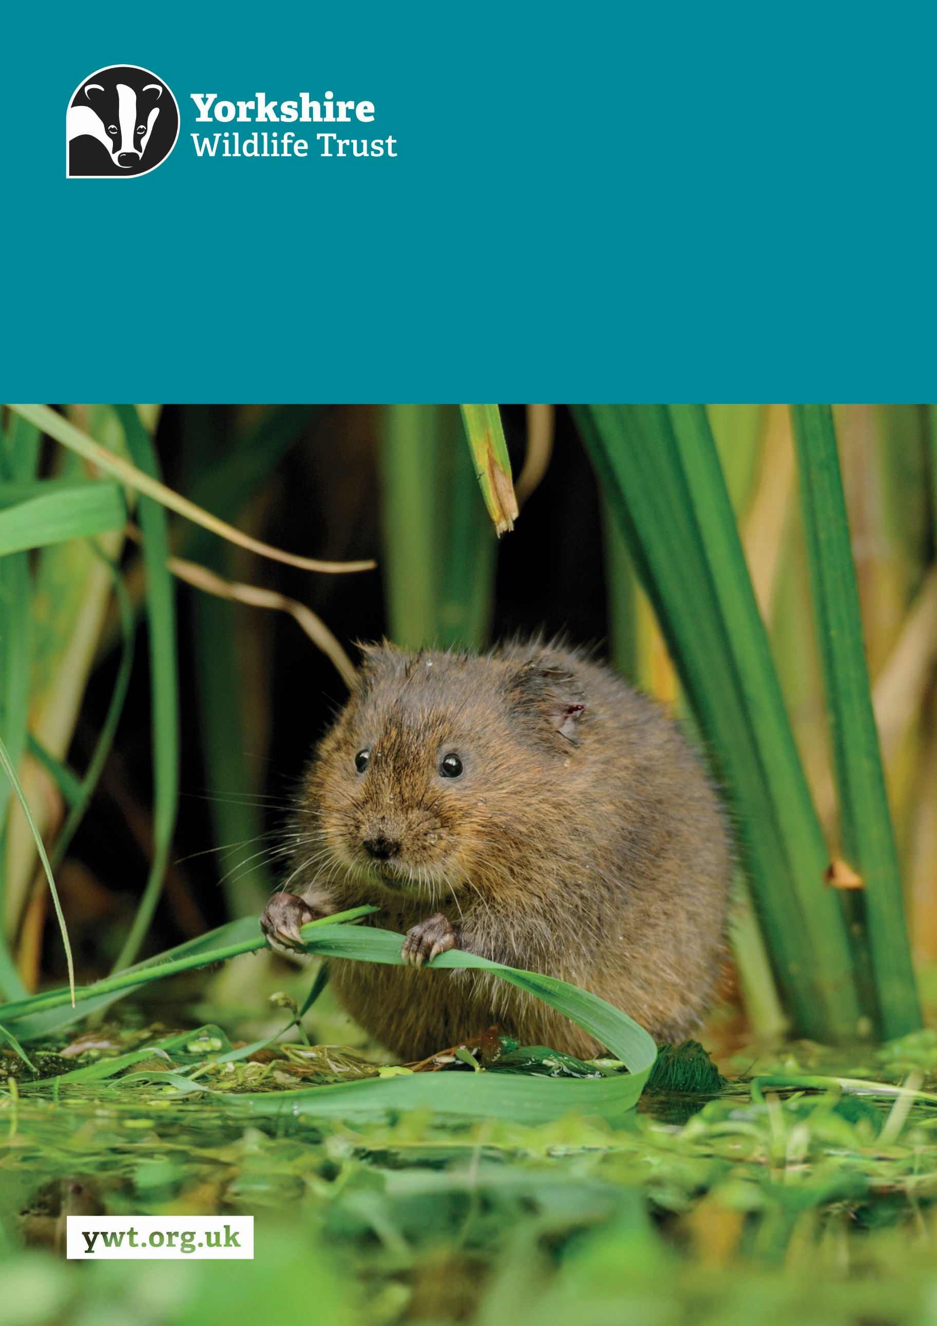
Z
Research and Evidence Specialist
Job Description
About us

Yorkshire Wildlife Trust is one of the region’s largest environmental charities; our mission is to drive nature’s recovery in Yorkshire across our land and at sea.
We are one of 46 regional Wildlife Trusts working for nature and collectively forming the Wildlife Trusts, one of the largest collective national movements for wildlife in Europe.
Our vision is for wildlife and people thrive together across Yorkshire’s communities, land, rivers and sea. We work holistically in nature, thinking globally, planning at regional and landscape scale, while delivering our work in partnership with local communities, caring for local wildlife together. Our dedicated team of staff (c.190) and volunteers (c.1000) work together, on behalf of all our members (c.41,000), in every corner of Yorkshire to make this vision a reality.

Since forming in 1946 with our first reserve at Askham Bog, we now steward 115 nature reserves, which cover more than 3,000 hectares of land and include some of our most precious wildlife. We also work extensively with other land managers, communities and businesses, to inspire, advise and deliver restoration work, supporting others too play their part in nature’s recovery.

We are passionate advocates for Yorkshire’s incredible wildlife and wild places. Join us and help create a diverse and inclusive team, committed to driving change for Yorkshire’s wildlife, communities and a positive future.

Job Description
Research and Evidence Specialist
Responsible To: Conservation Evidence and Impact Manager
Responsible for: Volunteers and contractors as required
Location/based at: Office location can be Doncaster, Huddersfield, York or Skipton with home working. Requirement to travel across Yorkshire to visit Trust offices, landholdings and development sites
Date last updated: 12 August 2026

Main Purpose of the Role
Data and evidence are fundamental to effective nature recovery. Robust research design ensures that conservation questions are clearly framed, methods are proportionate and appropriate, and findings can be used with confidence to target action, assess impact and adapt management. Yorkshire Wildlife Trust uses an evidence-informed approach to make better decisions and demonstrate real outcomes for nature.

Requiring strong ecological research design, analytical and communication skills, the Research and Evidence Specialist will support the design, delivery and application of ecological research, monitoring, survey approaches, habitat and species modelling, and evidence reporting across our nature reserves and landscapes. The role will promote excellence in how the Trust frames answerable conservation questions, designs methods to address them, analyses complex ecological and spatial data, and communicates findings, uncertainty and recommendations.

In doing so, the role will help translate ecological data and research into practical insights that support nature recovery across Yorkshire, including delivery of Bringing Yorkshire’s Nature Back and wider ambitions for 30% of land and sea to be positively managed for nature.

Tasks and responsibilities
Research Design, Data Management and Analysis
- Work with colleagues and partners to clarify evidence needs, frame answerable conservation questions, and design proportionate ecological research, monitoring and survey approaches.
- Develop and apply robust survey designs, standards and protocols for established and emerging ecological monitoring methods, including infra-red cameras, bioacoustics, remote sensing, eDNA and other technologies, ensuring methods are proportionate, repeatable, ethical, and capable of generating reliable evidence.
- Compile, manage and analyse ecological datasets from monitoring programmes, research studies, volunteer surveys and public databases, ensuring data collection and analysis are aligned with clear research or monitoring questions.
- Ensure data quality, reproducibility, transparency, version control and appropriate documentation across research design, data collection, analysis and reporting workflows.

Ecological Modelling and Analysis
- Select and apply appropriate methods for ecological and spatial analysis, including statistical analysis, hypothesis testing, modelling and the interpretation of uncertainty.
- Apply specialist ecological judgement to assess sampling design, bias, detectability, data limitations and the reliability of conclusions drawn from survey, monitoring and research data.
- Develop, document and maintain transparent, reproducible analytical workflows using appropriate tools such as R, Python, GIS and data visualisation software.
- Design, develop and apply ecological and spatial models, including species distribution modelling, habitat suitability modelling, connectivity analysis and population viability analysis, ensuring assumptions, limitations and appropriate uses are clearly documented.
- Critically interpret analytical outputs, model results and uncertainty, drawing proportionate conclusions and identifying where further evidence, caution or specialist input is required.

Evidence for Conservation Strategy and Policy
- Translate analytical findings, uncertainty and technical limitations into clear reports, evidence summaries, visualisations and recommendations for conservation delivery, land management, strategy and policy influence.
- Support the integration of robust, decision-useful evidence into conservation planning, project design, adaptive management and policy development across Trust work.
- Provide technical evidence input into conservation strategies, funding proposals, programme evaluations and policy positions, ensuring conclusions are proportionate to the quality and limits of the available evidence.
- Contribute to the periodic review of State of Yorkshire’s Nature and Bringing Yorkshire’s Nature Back, including the development of indicators, baselines, analytical approaches and reporting to monitor progress towards nature recovery goals.
- Work with conservation practitioners, ecologists and external partners, including academic institutions and NGOs, to align evidence generation and interpretation with conservation delivery priorities, LNRS monitoring and blueprint delivery.
- Keep up to date with relevant research methods, conservation evidence and emerging findings, sharing learning across the Trust to strengthen evidence-informed practice.

Management responsibilities
- Manage NRD research volunteers, interns and students, providing a nurturing team environment that supports personal and technical development while inspiring high-quality outcomes.
- Manage relevant research and evidence projects to ensure they meet agreed objectives, deadlines and budgets.
- Work with the Conservation Evidence & Insight Manager and Fundraising & Engagement Directorate to secure external funding for projects and staff posts, including developing project scopes and budgets for funding proposals.

Other
- Promote the Trust and partner organisations whenever possible.
- Demonstrate our Trust values every day.
- Support and promote the Trust’s commitment to equality, diversity and inclusion.
- The Trust is committed to safeguarding and promoting the welfare of children, young people, and adults at risk and expects all staff and volunteers to share this commitment.
- Abide by all Trust policies.
- Undertake any other duties as requested by your line manager and in line with the post.

Person Specification – Research and Evidence Specialist
Experience | Essential/Desirable
Experience of designing and delivering ecological research, monitoring and survey projects that start with clear conservation questions and use appropriate research design, survey methods, data collection, analysis, interpretation and reporting to generate robust, decision-useful evidence. | Essential
Experience developing or applying survey designs, standards and protocols for ecological monitoring methods, including infra-red cameras, bioacoustics, remote sensing, eDNA or other technologies. | Essential
Experience working with modelling frameworks or tools (e.g. VORTEX, Circuitscape, MaxEnt, Bayesian models). | Essential
Experience working with spatial data and integrating analysis with GIS outputs. | Essential
Experience producing high-quality technical reports, evidence summaries, visualisations and recommendations that clearly communicate analytical findings and their implications for conservation action to technical and non-technical audiences. | Essential
Experience designing monitoring and evaluation frameworks, including indicators, baselines and review methods, to track ecological outcomes, assess impact and inform adaptive management. | Essential
Knowledge and Skills | Essential/Desirable
Strong technical knowledge of ecological research and survey design, including sampling approaches, statistical power, bias, detectability, data limitations, survey standards and how methodological choices affect the reliability of conclusions. | Essential
Strong analytical skills, with experience of applying appropriate statistical, spatial and/or modelling methods to test hypotheses, evaluate ecological change, identify patterns and communicate uncertainty. | Essential
Proficiency in analytical tools such as R, Python, GIS and data visualisation software, with the ability to produce transparent, reproducible and well-documented analytical workflows. | Essential
A strong understanding of data quality assurance, version control, and documentation best practices. | Essential
Ability to translate research findings, analytical outputs and uncertainty into practical recommendations for conservation delivery, land management, strategy or policy influence. | Essential
Ability to interpret complex ecological and spatial datasets, draw proportionate conclusions, communicate uncertainty, and explain the implications for conservation decisions and strategic priorities. | Essential
Highly IT literate, particularly MS Office products and GIS. | Essential
Excellent written, verbal and visual communication skills, with the ability to present complex evidence clearly to technical and non-technical audiences. | Essential
Effective time management skills, particularly in managing multiple priorities within tight funding and project timescales. | Essential
Knowledge of relevant conservation policy, legislation, or reintroduction guidelines. | Desirable
Personal Qualities
A methodical approach with strong organisational skills and attention to detail. | Essential
A willingness to learn and work under own initiative. | Essential
Persuasive and courteous when dealing with internal and external stakeholders and a wide range of audiences. | Essential
Commitment to nature conservation and the importance of data in underpinning all work that the Trust undertakes. | Essential
Able to work independently and collaboratively across teams. | Essential

Qualifications and Other Requirements
An advanced degree (MSc or PhD) in ecology, conservation science, environmental science, or related field (or able to demonstrate equivalent knowledge and experience). | Essential
Willing and able to travel across Yorkshire to visit a range of YWT offices and sites, and to meet stakeholders as necessary. | Essential

Terms and Conditions
Salary: | £33,038.72 - £36,357.36 per annum (pro rata if part-time).
Hours: | 35 hours per week, Monday to Friday. The nature of the post’s duties may occasionally require evening and/or weekend work.  Paid overtime is not available, but time off in lieu will be given for essential additional hours worked.
Contract: | Permanent. A probationary period of 4 months applies to new staff, during which you must complete all essential, mandatory training.
Flexibility: | Whilst ensuring the needs of the business and the role are met, the Trust endeavours to meet the flexible working needs of its employees. Depending on the nature of the role, the Trust offers hybrid working (a mix of office and at home).
Holidays: | 30 days per annum inclusive of 3 office/site closure days over the Christmas period, in addition to national public holidays, rising to 33 days after 5 years’ service. All leave is pro rata for part time employees.
Pensions: | You may be eligible to be auto enrolled into the Trust’s Pension Scheme. Terms of the scheme are available on request from Finance.
Employee Assistance Programme: | The Trust provides an Employee Assistance Programme. This is a confidential service which aims to provide staff with support for a range of issues.
Health Questionnaire: | You will be asked to complete a health questionnaire in order to identify and support or adjustments you may require.
Equal Opportunities: | Yorkshire Wildlife Trust is committed to equal opportunities and appoints on merit. We welcome applicants from all sections of society regardless of gender, sexual orientation, race, disability, marital status, age and religion, perceived community background or political beliefs.
Place of Work: | Office location can be Doncaster, Huddersfield, York or Skipton with home working. Postholder is required to travel across Yorkshire to visit YWT offices, landholdings, development sites.
Travel: | Public transport is encouraged although pool vehicles are available. In exceptional circumstances the use of the employee’s own vehicle may be necessary for business use, at a mileage rate of 55p per mile.
Training & Professional Memberships: | The Trust is fully committed to personal development and training and supports achieving and maintaining professional memberships and accreditations, with any essential-to-role professional memberships paid for by the Trust.

