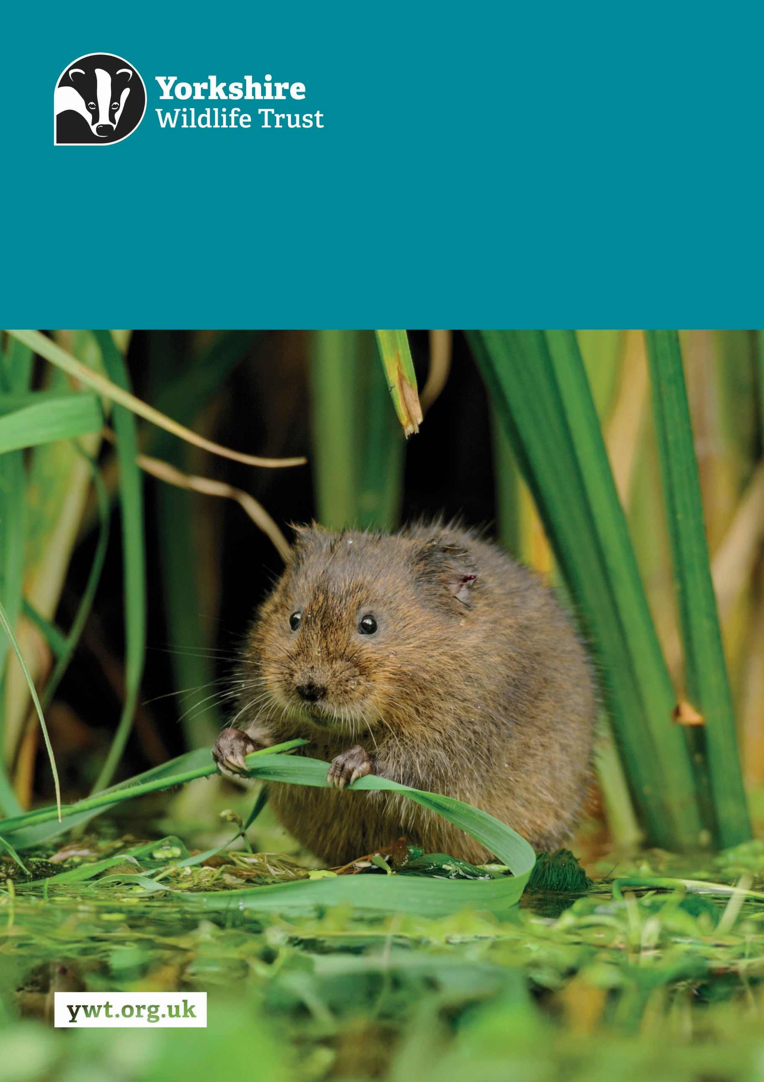
Z
Peat Project Officer
Job Description
About us

Yorkshire Wildlife Trust is one of the region’s largest environmental charities; our mission is to drive nature’s recovery in Yorkshire across our land and at sea.
We are one of 46 regional Wildlife Trusts working for nature and collectively forming the Wildlife Trusts, one of the largest collective national movements for wildlife in Europe.
Our vision is for wildlife and people thrive together across Yorkshire’s communities, land, rivers and sea. We work holistically in nature, thinking globally, planning at regional and landscape scale, while delivering our work in partnership with local communities, caring for local wildlife together. Our dedicated team of staff (c.190) and volunteers (c.1000) work together, on behalf of all our members (c.41,000), in every corner of Yorkshire to make this vision a reality.

Since forming in 1946 with our first reserve at Askham Bog, we now steward 115 nature reserves, which cover more than 3000 hectares of land and include some of our most precious wildlife. We also work extensively with other land managers, communities and businesses, to inspire, advise and deliver restoration work, supporting others too play their part in nature’s recovery.

We are passionate advocates for Yorkshire’s incredible wildlife and wild places. Join us and help create a diverse and inclusive team, committed to driving change for Yorkshire’s wildlife, communities and a positive future.

Job Description
Peat Project Officer
Responsible for: Project Assistants (depending on experience)
Responsible to: Peat Project Manager
Location/based at: YWT regional office in Skipton with hybrid working
Date last updated: 23 March 2026
Main Purpose of the Role
The Project Officer will work as part of Yorkshire Peat Partnership’s Restoration Team, delivering peat restoration across multiple sites in the Yorkshire Dales, Nidderdale National Landscape, North York Moors and South Pennines. It is a varied role which utilises a wide range of skills including project management, ecology and hydrology, peatland surveys, QGIS and stakeholder management.
Tasks and responsibilities
Surveying
      - Utilising QGIS to map erosion features, leading on field surveys collecting ecological and hydrological data on peatland sites, interpreting and mapping the data collected.
Report writing
      - Producing detailed peat restoration plans, recommending restoration interventions and creating associated maps.
Stakeholder management
      - Agreeing access arrangements, completing service contracts, liaising with external partners, and chairing restoration plan meetings with landowners, farm tenants and agents.

Co-ordinating and overseeing capital works
      - Liaising with archaeologists, engaging with specialised peatland contractors, sharing spatial data, completing Clerk of Works checks, tendering and budget tracking.
Consents / Permission
      - Ensuring surveys and capital works have all the necessary permissions for work to be carried out. Liaising with the Environment Agency, Natural England and local authorities.
Health & Safety
      - Completing risk assessments, managing contractors on site, completing CDM documentation and ensuring sites are HSE compliant.

Teaching Support
- Deliver or assist with sessions of our external training programme.
Other
- Promote the Trust and partner organisations whenever possible.
- Demonstrate our Trust values every day behaving with courage, respect, and integrity whilst trusting others and taking responsibility for your actions at all times.
- Support and promote the Trust’s commitment to equality, diversity and inclusion.
- The Trust is committed to safeguarding and promoting the welfare of children, young people, and adults at risk and expects all staff and volunteers to share this commitment.
- Abide by all Trust policies.
- Undertake any other duties as requested by your line manager and in line with the post.

Person Specification
Experience | Essential/Desirable
Working in land management for nature recovery | Essential
Representing an organisation in a professional environment | Essential
Practical application of GIS software | Essential
Ecological field survey work | Essential
Contractor management | Desirable
Tendering contracts | Desirable
Line management | Desirable
Knowledge and Skills | Essential/Desirable
Excellent IT skills and literacy, confident in using full Microsoft Office suite and easily able to learn new programs and software | Essential
Excellent organisational skills | Essential
Excellent professional written and verbal communication skills | Essential
A good understanding of health and safety, preferably in relation to large capital projects | Essential
Upland botanical identification | Desirable
A good understanding of peatland ecology and management | Desirable
Project management | Desirable
Personal Qualities | Essential/Desirable
Ability to communicate with enthusiasm, tact, diplomacy and confidence to a number of different audiences | Essential
Ability to work on multiple projects, keep to deadlines, budget and show high attention to detail | Essential
Willingness and ability to spend long periods of time in challenging, remote environments, including separated working on exposed moorland in all weathers | Essential
A common-sense approach to solving problems | Essential
Able to work in a busy, evolving environment with a team of colleagues with varying skills and abilities | Essential
Flexible and able to respond to changing circumstances at short notice | Essential
Excellent time-keeping and punctuality | Essential
An interest in and enthusiasm for the work of Yorkshire Wildlife Trust and the Peat Programme | Essential
Essential Qualifications/Requirements | Essential
A full driving licence in order to travel to remote sites and locations | Essential
Qualifications or equivalent experience relating to practical land management, ecology, environmental science or similar | Essential
Willingness to work outside normal office hours, including some stays away from home during the survey season | Essential

Terms and Conditions
Salary: | £28,804.88 - £32,043.44 per annum (pro rata if part-time).
Hours: | 35 hours per week, Monday to Friday.  The nature of the post’s duties may occasionally require occasional evening and/or weekend work.  Paid overtime is not available, but time off in lieu will be given for essential additional hours worked.
Contract: | Fixed Term for 1 year. A probationary period of 4 months applies to new staff, during which you must complete all essential, mandatory training.
Flexibility: | Whilst ensuring the needs of the business and the role are met, the Trust endeavours to meet the flexible working needs of its employees. Depending on the nature of the role, the Trust offers hybrid working (a mix of office and at home).
Holidays: | 30 days per annum inclusive of 3 office/site closure days over the Christmas period, in addition to national public holidays, rising to 33 days after 5 years’ service. All leave is pro rata for part time employees.
Pensions: | You may be eligible to be auto enrolled into the Trust’s Pension Scheme. Terms of the scheme are available on request from Finance.
Employee Assistance Programme: | The Trust provides an Employee Assistance Programme. This is a confidential service which aims to provide staff with support for a range of issues.
Health Questionnaire: | You will be asked to complete a health questionnaire in order to identify and support or adjustments you may require.
Equal Opportunities: | Yorkshire Wildlife Trust is committed to equal opportunities and appoints on merit. We welcome applicants from all sections of society regardless of gender, sexual orientation, race, disability, marital status, age and religion, perceived community background or political beliefs.
Place of Work: | The post will be based at YWT Regional Office, Skipton
Travel: | Public transport is encouraged although pool vehicles are available. In exceptional circumstances the use of the employee’s own vehicle may be necessary for business use, at a mileage rate of 55p per mile.
Training & Professional Memberships: | The Trust is fully committed to personal development and training and supports achieving and maintaining professional memberships and accreditations, with any essential-to-role professional memberships paid for by the Trust.

