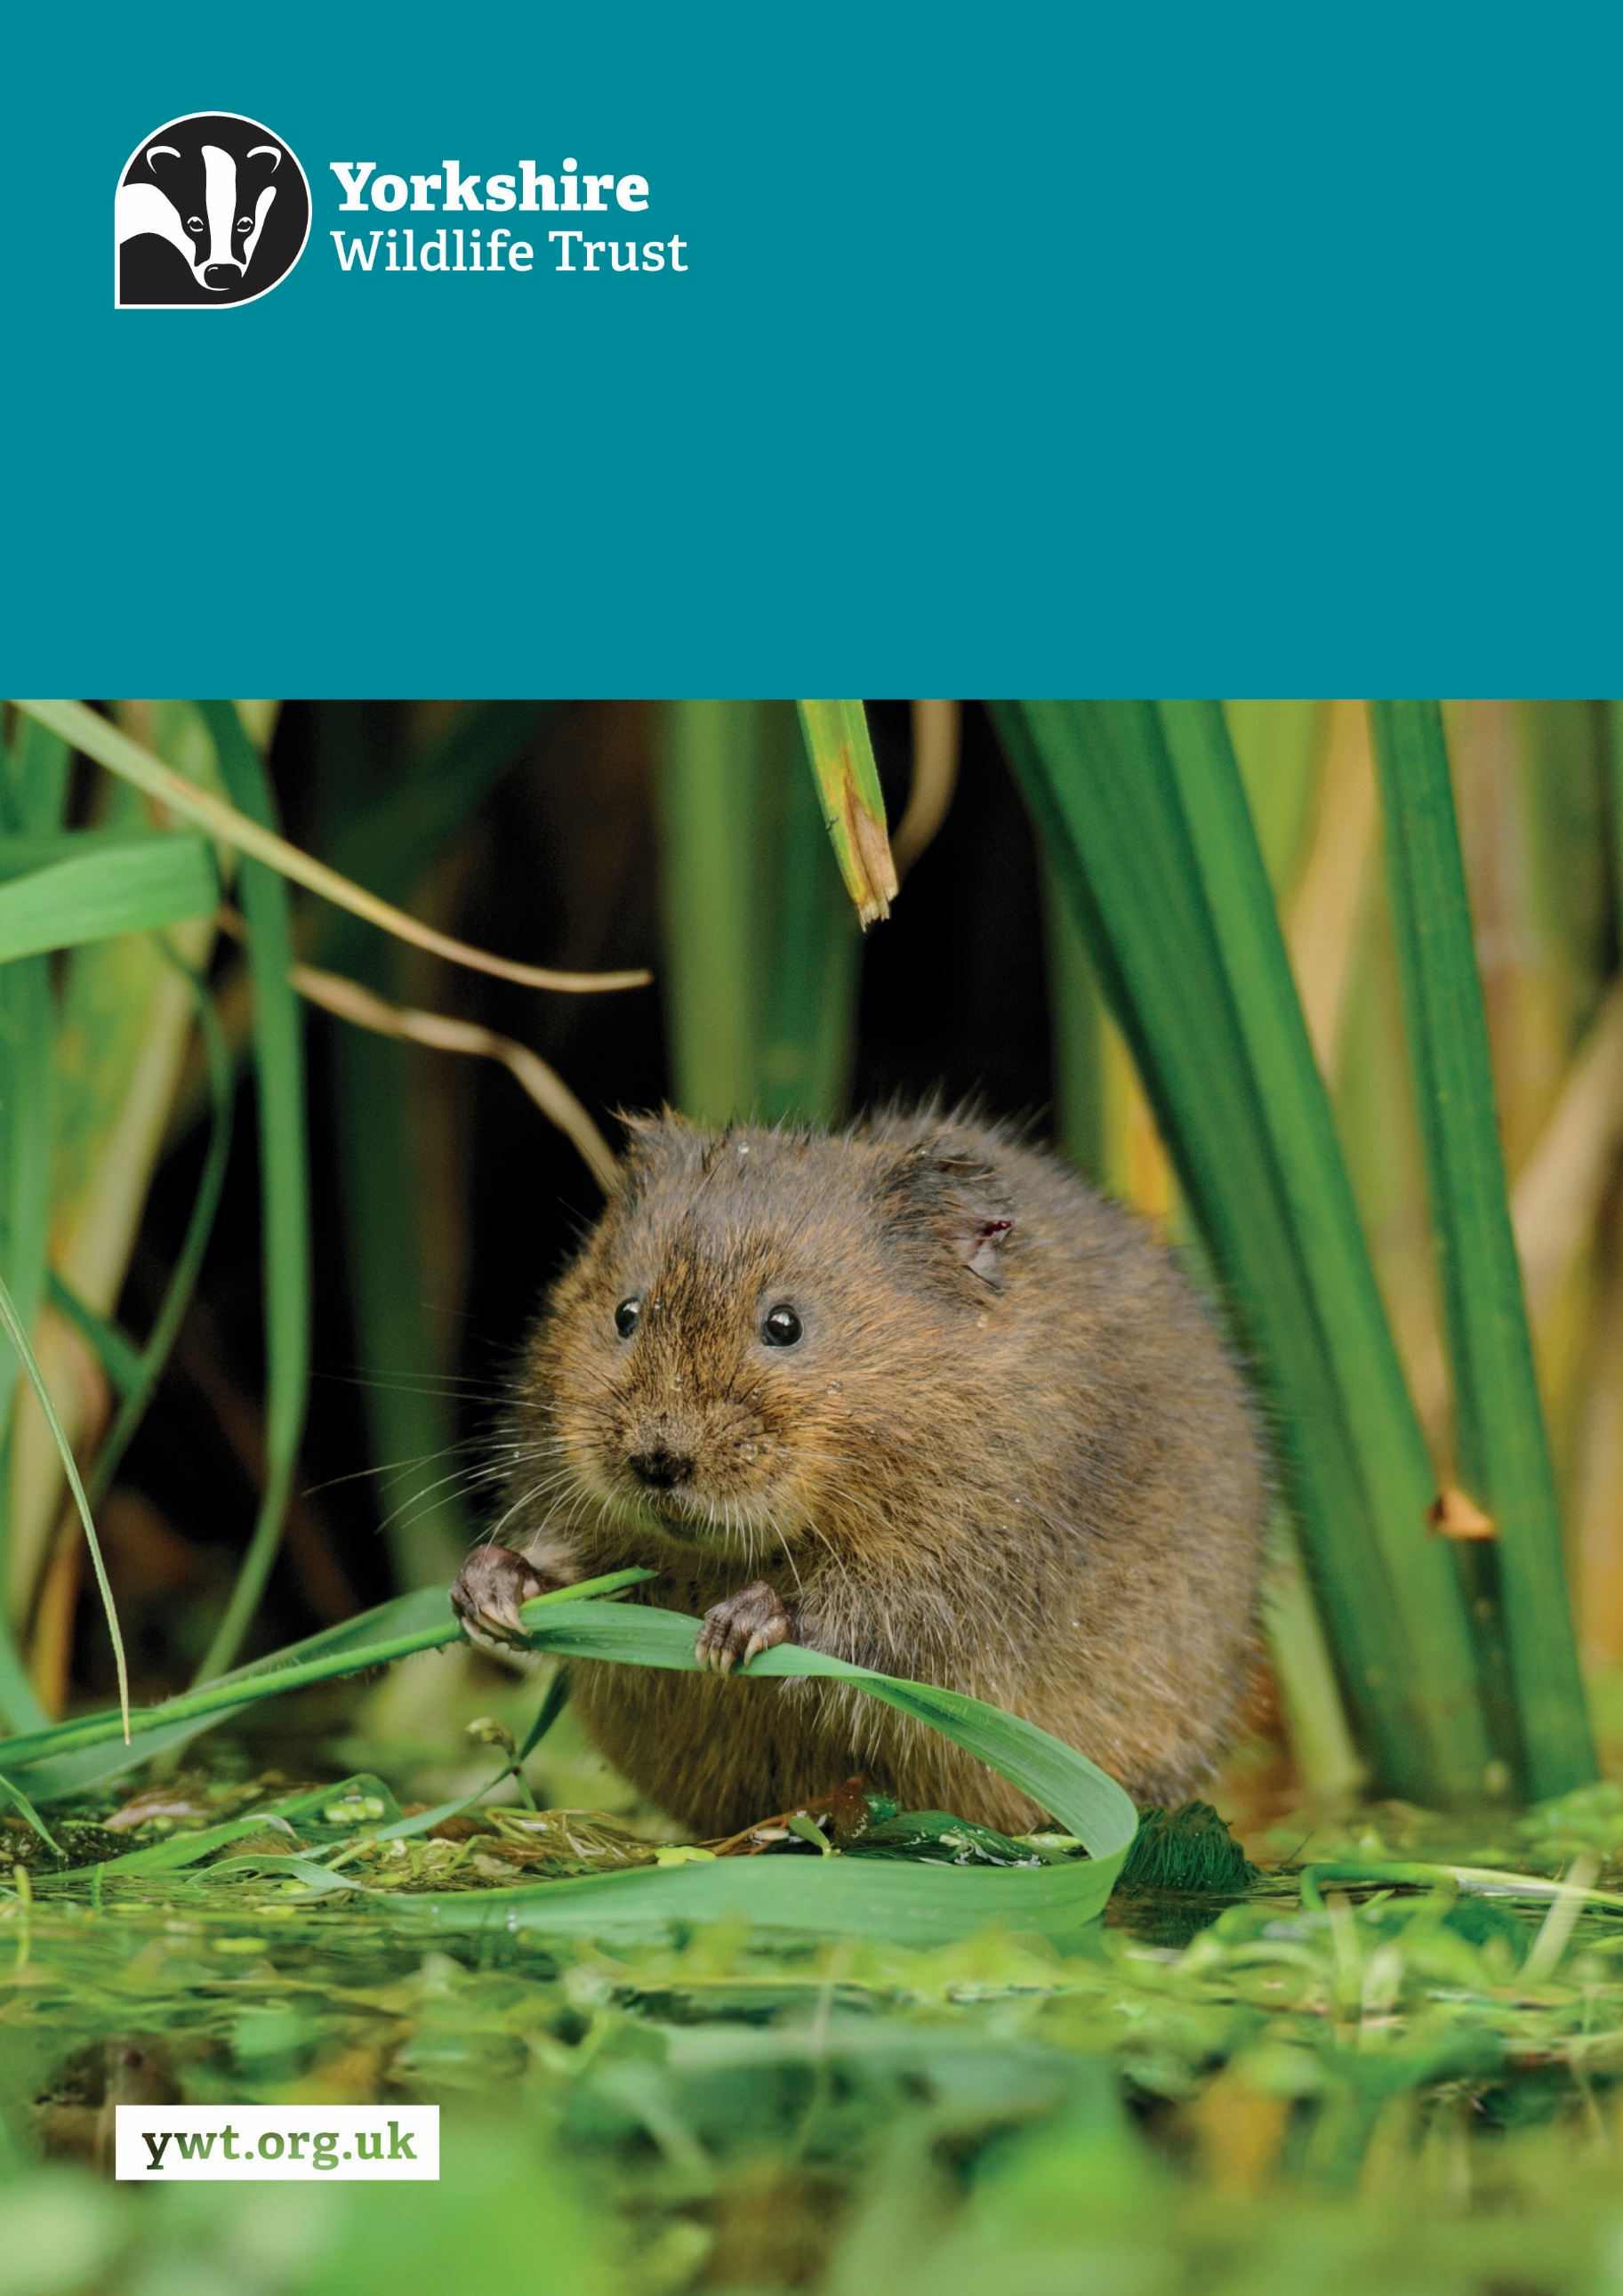
Z
Marine Restoration Officer Job Description
About us

Yorkshire Wildlife Trust is one of the region’s largest environmental charities; our mission is to drive nature’s recovery in Yorkshire across our land and at sea.
We are one of 46 regional Wildlife Trusts working for nature and collectively forming the Wildlife Trusts, one of the largest collective national movements for wildlife in Europe.
Our vision is for wildlife and people thrive together across Yorkshire’s communities, land, rivers and sea. We work holistically in nature, thinking globally, planning at regional and landscape scale, while delivering our work in partnership with local communities, caring for local wildlife together. Our dedicated team of staff (c.190) and volunteers (c.1000) work together, on behalf of all our members (c.41,000), in every corner of Yorkshire to make this vision a reality.

Since forming in 1946 with our first reserve at Askham Bog, we now steward 115 nature reserves, which cover more than 3000 hectares of land and include some of our most precious wildlife. We also work extensively with other land managers, communities and businesses, to inspire, advise and deliver restoration work, supporting others too play their part in nature’s recovery.

We are passionate advocates for Yorkshire’s incredible wildlife and wild places. Join us and help create a diverse and inclusive team, committed to driving change for Yorkshire’s wildlife, communities and a positive future.

Job Description
Marine Restoration Officer

Responsible to: Marine Restoration Manager

Responsible for: Task allocation/supervision of the Marine Restoration Assistant and Volunteer

Location/based at: Spurn Point, Hull

Date last updated: 28 July 2025

Main Purpose of the Role:

- Coordinate and deliver allocated seagrass and native oyster restoration workstreams at Spurn Point and across the Humber Estuary, under the direction of the Marine Restoration Manager.

- Take day-to-day responsibility for the Trust’s seagrass restoration, intertidal oysters, aquaria and associated equipment, including routine husbandry, maintenance and biosecurity.

- Plan and organise restoration activities, monitoring, resources and associated administration, ensuring that multiple priorities and deadlines are managed effectively and that accurate project records and reports are maintained.

- Work as part of the wider Humber Restoration Team, supporting integrated dune, saltmarsh, seagrass and native oyster restoration; representing the project at public and technical forums; and contributing to engagement activities and events.

- The role requires some weekend and irregular-hours working in response to tidal and operational requirements.

Tasks and responsibilities:

Technical

- Carry out allocated seagrass and native oyster restoration work at Spurn, Horseshoe Point and any additional project sites.
- Undertake routine husbandry and maintenance at the oyster trestles, seagrass nursery, aquaria and associated restoration facilities.
- Plan and coordinate assigned activities, orders, materials, equipment and logistics, maintaining oversight of multiple workstreams, dependencies and deadlines.
- Implement and maintain appropriate biosecurity procedures across restoration facilities and field activities.
- Support compliance with relevant licences, consents and permissions, maintaining accurate records and completing required documentation.
- Undertake regular monitoring and trials to assess restoration success, growth, condition, productivity and the effectiveness of restoration methods.
- Deliver ecological and environmental surveys, including benthic, fish, avian, water-quality and wider ecosystem monitoring associated with seagrass and native oyster restoration.
- Accurately record, manage, analyse and interpret monitoring data, using GIS and other appropriate software to produce maps, reports, presentations and project outputs.
- Support project colleagues in delivering technical surveys, practical workdays and site works across dune, saltmarsh, seagrass and native oyster restoration.

Policy and procedure

- Undertake the necessary health and safety preparation for fieldwork, facilities and volunteer activities, including risk assessments and associated documentation.
- Support the safe day-to-day operation of the Trust’s marine assets and facilities, maintaining accurate health and safety, maintenance, husbandry and operational records.
- Ensure activities are undertaken in accordance with relevant statutory consents, licences, permissions and Trust procedures.
- Maintain and apply site biosecurity protocols, promptly reporting any breaches, risks or operational concerns.
- Follow the Trust’s financial, procurement and budgetary procedures, maintaining accurate records of orders, expenditure and resources associated with allocated workstreams.

Management of volunteers and engaging local communities

- Plan and lead volunteer and corporate workdays, ensuring activities are appropriately prepared, briefed, supervised and delivered safely and effectively.
- Support the recruitment, induction, training and supervision of volunteers and voluntary trainees, and allocate day-to-day tasks to the Marine Restoration Assistant where appropriate.
- Represent Yorkshire Wildlife Trust professionally at project sites, public events, conferences and technical meetings, supporting engagement activities and communicating the purpose and outcomes of the restoration work.

Other duties:

- Promote the Trust and partner organisations whenever possible.
- Demonstrate our Trust values every day.
- Support and promote the Trust’s commitment to equality, diversity and inclusion.
- The Trust is committed to safeguarding and promoting the welfare of children, young people, and adults at risk and expects all staff and volunteers to share this commitment.
- Abide by all Trust policies.
- Undertake any other duties as requested by your line manager and in line with the post.

Person Specification
Experience | Essential/Desirable
Experience of planning and delivering practical marine, coastal or relevant environmental conservation or restoration work | Essential
Experience of undertaking aquaria, aquaculture or marine nursery husbandry and routine maintenance | Essential
Experience of ecological or environmental surveying and monitoring, including accurate field data collection | Essential
Experience of planning and coordinating multiple activities, priorities and deadlines, including maintaining accurate project or operational records | Essential
Experience of analysing environmental data and communicating findings through reports, maps or presentations | Essential
Experience of leading or supervising colleagues, volunteers, trainees or practical work groups | Essential
Experience of working safely in remote, coastal, exposed or otherwise challenging conditions | Essential
Practical experience of seagrass and/or native oyster restoration | Desirable
Knowledge and Skills | Essential/Desirable
Good knowledge of the marine environment, coastal habitats and the principles of habitat restoration | Essential
Ability to manage, analyse and interpret ecological or environmental data | Essential
Ability to use GIS or spatial-data software to record, analyse or present environmental information | Desirable
Strong organisational, administrative and project-planning skills, with the ability to manage competing priorities and deadlines | Essential
Strong attention to detail and the ability to maintain accurate, complete and consistent records | Essential
Clear written and verbal communication skills, including technical reporting and confidence communicating with group audiences | Essential
Effective partnership-working and interpersonal skills, with the ability to work with colleagues, volunteers, communities and external organisations | Essential
Practical problem-solving skills and a sound understanding of health and safety and biosecurity within marine or field environments | Essential
Personal Qualities | Essential/Desirable
Well organised, dependable and committed to completing work accurately and on time | Essential
Ability to think on one’s feet and respond proactively to emerging situations | Essential
Self-motivated and able to manage their own workload within an agreed workstream | Essential
Able to work autonomously while remaining accountable to the Marine Restoration Manager and wider team | Essential
Flexible, adaptable and able to work effectively with people from a range of backgrounds | Essential
Essential Qualifications/Requirements | Essential
A full driving licence valid for driving in the UK, with the willingness and ability to travel regularly to remote sites and reserves | Essential
Willing and able to undertake practical and manual outdoor activities throughout the year, including occasional weekend and irregular-hours work associated with tidal and operational requirements | Essential

Terms and Conditions
Salary: | £28,804.88 - £32,043.44 per annum.
Hours: | 35 hours per week, Monday to Friday.  The nature of the post’s duties may occasionally require evening and/or weekend work. Paid overtime is not available, but time off in lieu will be given for essential additional hours worked.
Contract: | Fixed Term (1 year). A probationary period of 4 months applies to new staff, during which time you must complete all essential, mandatory training.
DBS: | An offer of employment for this role will be subject to a satisfactory disclosure and barring check. DBS checks will be repeated every 3 years unless there is a reason to request one earlier.
Flexibility: | Whilst ensuring the needs of the business and the role are met, the Trust endeavours to meet the flexible working needs of its employees. Depending on the nature of the role, the Trust offers hybrid working (a mix of office and at home).
Holidays: | 30 days per annum inclusive of 3 office/site closure days over the Christmas period, in addition to national public holidays, rising to 33 days after 5 years’ service. All leave is pro rata for part time employees.
Pensions: | You may be eligible to be auto enrolled into the Trust’s Pension Scheme. Terms of the scheme are available on request from Finance.
Employee Assistance Programme: | The Trust provides an Employee Assistance Programme. This is a confidential service which aims to provide staff with support for a range of issues.
Health Questionnaire: | You will be asked to complete a health questionnaire in order to identify and support or adjustments you may require.
Equal Opportunities: | Yorkshire Wildlife Trust is committed to equal opportunities and appoints on merit. We welcome applicants from all sections of society regardless of gender, sexual orientation, race, disability, marital status, age and religion, perceived community background or political beliefs.
Place of Work: | The post will be based at Spurn Point, Hull.
Travel: | Public transport is encouraged although pool vehicles are available. In exceptional circumstances the use of the employee’s own vehicle may be necessary for business use, at a mileage rate of 55p per mile.
Training & Professional Memberships: | The Trust is fully committed to personal development and training and supports achieving and maintaining professional memberships and accreditations, with any essential-to-role professional memberships paid for by the Trust.

