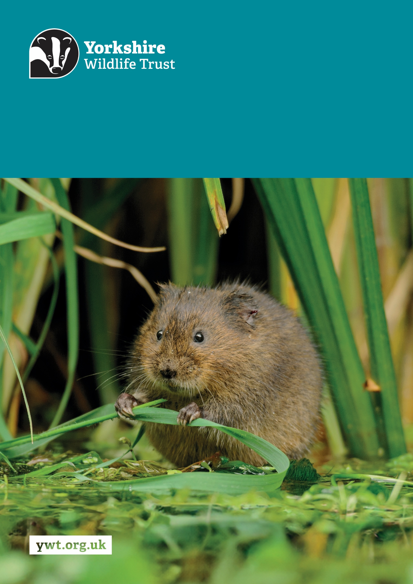
Z
Project Assistant Part Time
River Derwent & Vale of York
About us

Yorkshire Wildlife Trust is one of the region’s largest environmental charities; our mission is to drive nature’s recovery in Yorkshire across our land and at sea.
We are one of 46 regional Wildlife Trusts working for nature and collectively forming the Wildlife Trusts, one of the largest collective national movements for wildlife in Europe.
Our vision is for wildlife and people thrive together across Yorkshire’s communities, land, rivers and sea. We work holistically in nature, thinking globally, planning at regional and landscape scale, while delivering our work in partnership with local communities, caring for local wildlife together. Our dedicated team of staff (c.190) and volunteers (c.1000) work together, on behalf of all our members (c.41,000), in every corner of Yorkshire to make this vision a reality.

Since forming in 1946 with our first reserve at Askham Bog, we now steward 115 nature reserves, which cover more than 3000 hectares of land and include some of our most precious wildlife. We also work extensively with other land managers, communities and businesses, to inspire, advise and deliver restoration work, supporting others too play their part in nature’s recovery.

We are passionate advocates for Yorkshire’s incredible wildlife and wild places. Join us and help create a diverse and inclusive team, committed to driving change for Yorkshire’s wildlife, communities and a positive future.

Yorkshire Wildlife Trust is the catchment host for the Yorkshire Derwent Catchment Partnership (YDCP) Yorkshire Derwent - CaBA. This post supports both the work of the YDCP and our own reserves work programme.

Job Description
Job Title
Responsible for: Volunteers
Responsible to: Project Officer
Location/based at: 1 St. George’s Place, York, YO24 1GN
Date last updated: 02/12/2025

Main Purpose of the Role
- To support our Vale of York & Derwent Team to deliver the YDCP Invasive Non-Native Species (INNS) Catchment Strategy and support practical reserves work in autumn and winter. Yorkshire Derwent Catchment Partnership | Yorkshire Wildlife Trust
- To help native species to thrive, while protecting the stability of riverbanks and other waterways by treating INNS (mostly giant hogweed), a phototoxic species, with pesticides and liaising with landowners to further the treatment of INNS.
- To assist the delivery of the annual INNS control programme which is focused on the eradication of giant hogweed throughout the Derwent Catchment by 2030 and support producing the annual INNS treatment report and updating the INNS Catchment Strategy.
- To carry out many physical tasks in the early morning during the summer months in full PPE, with a full knapsack sprayer weighing up to 12 kg whilst navigating uneven ground.
- To work in public and private areas and engage with landowners.
- To assist the team on reserves and with the other projects delivering river restoration, natural flood management, and biodiversity projects and attain a good level of understanding of the catchment-based approach (CaBA).

Tasks and responsibilities
- Carry out practical invasive species treatment working with staff, landowners, partners, contractors and volunteers where necessary.
- Assist the Reserve assistant with practical tasks on reserves.
- Adhere to our Personal Protective Equipment (PPE) and biosecurity protocols.
- Deliver any scheduled events/shows and activities which raise awareness and understanding of the value of the project to relevant stakeholders.
- Work with and support coordination of volunteers including running task days and surveys.

Other
- Promote the YDCP, Yorkshire Wildlife Trust and partner organisations whenever possible.
- Demonstrate our Trust values every day behaving with courage, respect, and integrity whilst trusting others and taking responsibility for your actions at all times.
- Support and promote the Trust’s commitment to equality, diversity and inclusion.
- The Trust is committed to safeguarding and promoting the welfare of children, young people, and adults at risk and expects all staff and volunteers to share this commitment.
- Abide by all Trust policies.
- Undertake any other duties as requested by your line manager and in line with the post.

Person Specification
Experience | Essential/Desirable
Experience and capability of undertaking regular manual, practical tasks | Essential
Experience of practical invasive species management | Desirable
Experience of communicating with a range of people such as volunteers, contractors and landowners. | Desirable
Experience of safe and efficient use of hand tools. | Desirable
Experience of being/working with volunteers on practical tasks. | Desirable
Knowledge and Skills | Essential/Desirable
Good organisational and recording skills | Essential
Good communication and presentation skills | Essential
Good time management skills and ability to forward plan | Essential
Ability to diplomatically interact with people in a positive and proactive manner. | Essential
Good knowledge of invasive plant species | Desirable
Good knowledge of biosecurity best practice | Desirable
Experience of GiS and data entry | Desirable
Application of pesticides using knapsack sprayer in and around water (PA1 and PA6aW) and or stem injector (training provided as required) | Desirable
Personal Qualities | Essential/Desirable
Good level of fitness and mobility in order to undertake tasks for long periods in challenging outdoor environments | Essential
Self-motivated, able to manage own time and work as part of a team | Essential
Willing and able to problem solve and address issues as they arise | Essential
Essential Qualifications/Requirements | Essential
Willing and able to drive regularly to our remote sites and reserves | Essential
Full UK compatible driving licence | Essential

Terms and Conditions
Salary: | £23,750 per annum (pro rata if part-time).
Hours: | 21 hours per week, Monday to Friday. The nature of the post’s duties may require early morning (spraying season) and/or occasional weekend work.  Paid overtime is not available, but time off in lieu will be given for essential additional hours worked.
Contract: | Fixed Term to March 2027. A probationary period of 6 months applies to new staff, during which you must complete all essential, mandatory training.
Flexibility: | Whilst ensuring the needs of the business and the role are met, the Trust endeavours to meet the flexible working needs of its employees. Depending on the nature of the role, the Trust offers hybrid working (a mix of office and at home).
Holidays: | 30 days per annum inclusive of 3 office/site closure days over the Christmas period, in addition to national public holidays, rising to 33 days after 5 years’ service. All leave is pro rata for part time employees.
Pensions: | You may be eligible to be auto enrolled into the Trust’s Pension Scheme. Terms of the scheme are available on request from Finance.
Employee Assistance Programme: | The Trust provides an Employee Assistance Programme. This is a confidential service which aims to provide staff with support for a range of issues.
Health Questionnaire: | You will be asked to complete a health questionnaire in order to identify and support or adjustments you may require.
Equal Opportunities: | Yorkshire Wildlife Trust is committed to equal opportunities and appoints on merit. We welcome applicants from all sections of society regardless of gender, sexual orientation, race, disability, marital status, age and religion, perceived community background or political beliefs.
Place of Work: | The post will be based at 1 St. George’s Place, York, YO24 1GN
Travel: | Public transport is encouraged although pool vehicles are available. In exceptional circumstances the use of the employee’s own vehicle may be necessary for business use, at a mileage rate of 45p per mile.
Training & Professional Memberships: | The Trust is fully committed to personal development and training and supports achieving and maintaining professional memberships and accreditations, with any essential-to-role professional memberships paid for by the Trust.

