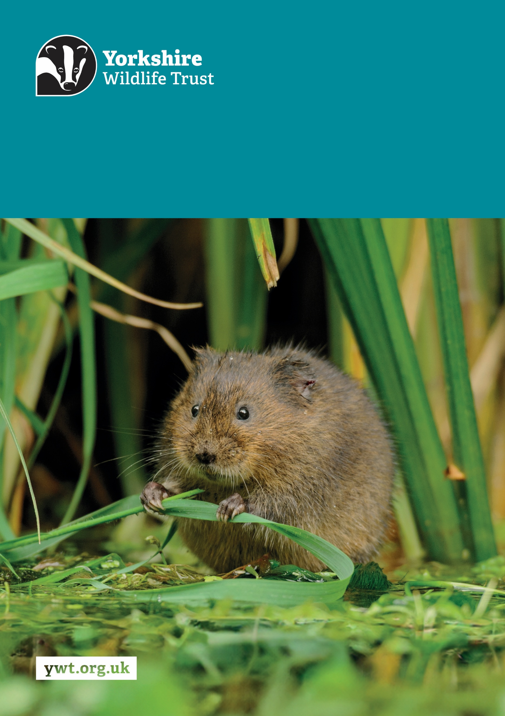
Z
Wilder Communities Officer - Urban
Job Description
About us

Yorkshire Wildlife Trust is one of the region’s largest environmental charities; our mission is to drive nature’s recovery in Yorkshire across our land and at sea.
We are one of 46 regional Wildlife Trusts working for nature and collectively forming the Wildlife Trusts, one of the largest collective national movements for wildlife in Europe.
Our vision is for wildlife and people thrive together across Yorkshire’s communities, land, rivers and sea. We work holistically in nature, thinking globally, planning at regional and landscape scale, while delivering our work in partnership with local communities, caring for local wildlife together. Our dedicated team of staff (c.190) and volunteers (c.1000) work together, on behalf of all our members (c.41,000), in every corner of Yorkshire to make this vision a reality.

Since forming in 1946 with our first reserve at Askham Bog, we now steward 115 nature reserves, which cover more than 3000 hectares of land and include some of our most precious wildlife. We also work extensively with other land managers, communities and businesses, to inspire, advise and deliver restoration work, supporting others too play their part in nature’s recovery.

We are passionate advocates for Yorkshire’s incredible wildlife and wild places. Join us and help create a diverse and inclusive team, committed to driving change for Yorkshire’s wildlife, communities and a positive future.

Job Description
Wilder Communities Officer - Urban
Responsible for: Volunteers
Responsible to: Community Engagement Manager
Location/based at: Potteric Carr, Doncaster. The focus for this role will be working in Doncaster with occasional work in other areas of Yorkshire such as Hull, Wakefield, Barnsley and Huddersfield.
Date last updated: September 2025

Main Purpose of the Role
- To connect with, listen to, and collaborate with a wide range of people, to build reciprocal trusted relationships at a local level to support and facilitate individuals, communities, and stakeholders to take meaningful actions for people and wildlife in their neighbourhoods.
- To spark and enhance people’s understanding of and passion for Yorkshire’s wildlife, wild places and the role people can play in restoring nature through inspiring events and activities delivered in the heart of urban areas and at our Nature Discovery Centre hubs.
- To establish credibility and trust through facilitating community-led action for wildlife that is well planned, organised and delivered safely and responsibly, while championing the Trust’s commitment to being fully inclusive, accessible, and reflective of Yorkshire’s diverse communities.
- To ensure that all community action for nature is taken of, by, for and with the community to help people to develop their collective power to act together, shaping change in their locality to reflect their priorities, needs, and vision for a community that is designed with wildlife in mind and encourages more people to join nature’s side, leading to a greener and more nature positive Yorkshire.
- To authentically share community voices and compelling stories of people making a difference for wildlife in their towns and cities to inspire support and mobilise sustained collective action for nature and climate to achieve 30 by 30 nationally.
Tasks and responsibilities
Mobilise and support people to come together to take meaningful, self-sustaining community action for wildlife in urban areas by:
- Establishing, through community mapping, curious listening and place-based organising where there are opportunities for people to address community need and aspirations by taking practical action to support nature’s recovery in urban neighbourhoods.
- Developing, through the process of co-creation and consultation, sustainable, relevant, and accessible interactive activities and experiences to be delivered by and for local groups, enabling them to connect with and act for wildlife.
- Supporting communities to build collective power, developing their ability to influence decisions, shape campaigns, and drive systems change in their neighbourhoods and across Yorkshire through their participation in movement wide campaigns.
- Working with local leaders, organisations, and community networks to build and maintain partnerships that amplify the voices of underrepresented communities and support community-driven action.
- Recruiting, managing and developing #TeamWilder Community Champion volunteers in keeping with Yorkshire Wildlife Trust’s volunteering policies to extend our reach, engage effectively with urban communities and assist with the delivery of our activities.
Spark and enhance people’s understanding and passion for Yorkshire’s wildlife, wild places and the role people can play in restoring nature by:
- Providing guidance to community groups by sharing our #TeamWilder toolkits, resources and delivering training sessions to grow knowledge and develop skills within urban communities, co-creating new audience-appropriate toolkits and training as required to catalyse and support effective, meaningful action for wildlife.
- Developing, promoting and delivering a high-quality programme of outreach events and experiences which are (where appropriate) financially generative, competitive in the marketplace and consistent with the wider Yorkshire Wildlife Trust offer.
- Providing opportunities for people to acquire the skills, knowledge and confidence to undertake independent action for the environment in their communities.
- Working with colleagues in other teams to identify opportunities to align our urban engagement activities to our wider nature reserve work and the development of our Nature Discovery Centres as hubs for local communities to connect with and act for nature.
Establish credibility and trust through facilitating community-led action for wildlife that is well planned, organised and delivered safely and responsibly by:
- Working alongside communities every step of the way to support their planning and delivery of actions; troubleshooting, coaching, sharing best practice and the experience of Trust colleagues to ensure all activity is delivered safely and responsibly.
- Upholding the Trust’s commitment to safeguarding and promoting the welfare of children, young people, and adults at risk.
- Championing the Trust’s commitment to being fully inclusive, accessible, and reflective of Yorkshire’s diverse communities.
- Undertaking robust risk assessments and following all relevant operational procedures and health and safety policies in delivering both real-world and digital engagement activities.
- Co-ordinating bookings for engagement programme activities, adhering to all relevant financial and data protection policies and regulations.
- Promoting environmental best practice through the design and delivery of engagement activities, e.g. single-use plastic free events and/or sensitive handling of wildlife.
Authentically share community voices and stories to inspire further action and mobilise support for nature’s recovery by:
- Capturing and sharing inspiring and compelling stories of people acting for wildlife in their towns and cities using photographs, video, audio and the written word.
- Co-creating relevant and impactful website and social media content with communities, including short, pre-recorded videos, reels and blogs, in keeping with Yorkshire Wildlife Trust’s style guide and brand guidelines.
- Enabling communities to have a platform on which to share their stories through the Trusts communication channels, local media, social media, and community networks.
Endeavour to bring about long-term change, ensuring #TeamWilder is effective and sustainable by:
- Monitoring and reporting on income and expenditure across all urban engagement activity (including externally funded projects) to the Community Engagement Manager.
- Securely gathering qualitative and quantitative participant data using established methods such as the Community Action for Nature App and regularly reporting on these and other agreed metrics within the #TeamWilder engagement programme.
- Embedding citizen science initiatives where appropriate by training and supporting communities to monitor local wildlife to evidence change and inform decision making.
- Promoting membership, developing the Trust’s chargeable outreach offers and ensuring that, where appropriate, our events and training courses cover their costs.
- Supporting the Community Engagement Manager in engaging local businesses in community initiatives and submitting funding applications to secure financial support for the delivery of measurable and targeted engagement projects.
- Working across teams to champion the Trust-wide transition to working in a model of community organising and embed the #TeamWilder ethos and approach across all our activities by building relationships and sharing ideas, learning, resources and best practice internally and with the Movement to support aligned campaigns and the effective delivery of our #TeamWilder objectives in Yorkshire.
- Proactively seeking out training and development opportunities to continually build talent and skills within the Community Engagement team.

Other
- Promote the Trust and partner organisations whenever possible.
- Demonstrate our Trust values every day behaving with courage, respect, and integrity whilst trusting others and taking responsibility for your actions at all times.
- Abide by all Trust policies.
- Undertake any other duties as requested by your line manager and in line with the post.
Person Specification
Experience | Essential/Desirable
Proven track record in community organising, grassroots activism, or working with communities to create change (formal or informal). | Essential
Experience of building trust and maintaining strong working relationships with colleagues, communities and stakeholders, working collaboratively with others to inspire support and increase participation. | Essential
Significant experience of co-creating and delivering projects, including working within agreed budgets and timescales, in a multi-disciplinary team. | Essential
Bringing people together through events, activities, or informal community gatherings. | Essential
Experience running workshops, delivering training, or supporting group learning in any setting. | Essential
Practical experience of recruiting, managing and supporting teams of volunteers. | Desirable
Using social media, community media, or creative tools to raise awareness, celebrate successes, or share stories to build a movement. | Desirable
Experience of using a range of monitoring and evaluation tools and techniques to measure impact. | Desirable
Knowledge and Skills | Essential/Desirable
Understanding of community organising, mobilising, grassroots activism, and how to facilitate people come together to create change. | Essential
Good knowledge and understanding of health and safety in the workplace, GDPR and safeguarding procedures. | Essential
Strong interpersonal and communication skills, with demonstrable experience of building and managing relationships with a diverse range of partners and participants. | Essential
Good project management skills; highly organised and resourceful with an ability to prioritise a large workload and stay organised in a fast paced, dynamic role while delivering competing priorities to tight deadlines. | Essential
Understanding of wildlife, nature conservation and environmental issues in the UK, especially those which are local to Yorkshire. | Essential
Proficient in the use of IT, especially of MS Office suite including Microsoft Word, Excel, PowerPoint and Outlook, as well as social media platforms, booking systems such as Eventbrite, and basic website CMS. | Essential
Skilled in capturing people stories using photographs, video and audio, and the use of editing software such as Adobe and Canva to create reels and videos. | Desirable
Personal Qualities | Essential/Desirable
A team player who can work collaboratively across multiple teams, community groups and projects. | Essential
A good listener and confident speaker, who demonstrates tact, diplomacy and integrity, is able to hold space, inspire trust, and can handle sensitive and confidential conversations. | Essential
Comfortable with uncertainty, adaptive in how you work, and creative in how you respond to challenges. | Essential
Passionate about supporting, advocating for and harnessing the skills, experience and knowledge of under-represented communities to make a difference. | Essential
Positive, enthusiastic and friendly nature with the ability to inspire confidence in others and confident in approaching and engaging a wide range of people in both informal and formal settings. | Essential
Committed to embedding equality, equity, diversity, and inclusion into everything you do, with an understanding of the importance of having a reflective, relevant and accessible ethos. | Essential
Passionate about nature and the environment, motivated by helping others to act and committed to campaigning for positive change. | Essential
Essential Qualifications/Requirements | Essential
DBS Check | Essential
A full UK driving licence, access to your own vehicle and a willingness and an ability to travel regularly within Yorkshire to meet communities and deliver events and activities in different locations. | Essential

Terms and Conditions
Salary: | £27,697 - £30,811 per annum.
Hours: | 35 hours per week, Monday to Friday.  The nature of the post’s duties will sometimes require evening and weekend work for events and community meetings.  Paid overtime is not available, but time off in lieu will be given for essential additional hours worked.
Contract: | Permanent. A probationary period of 6 months applies to new staff, during which you must complete all essential, mandatory training.
DBS: | An offer of employment for this role will be subject to a satisfactory disclosure and barring check. DBS checks will be repeated every 3 years unless there is a reason to request one earlier.
Flexibility: | Whilst ensuring the needs of the business and the role are met, the Trust endeavours to meet the flexible working needs of its employees. Depending on the nature of the role, the Trust offers hybrid working (a mix of office and at home).
Holidays: | 30 days per annum inclusive of 3 office/site closure days over the Christmas period, in addition to national public holidays, rising to 33 days after 5 years’ service. All leave is pro rata for part time employees.
Pensions: | You may be eligible to be auto enrolled into the Trust’s Pension Scheme. Terms of the scheme are available on request from Finance.
Employee Assistance Programme: | The Trust provides an Employee Assistance Programme. This is a confidential service which aims to provide staff with support for a range of issues.
Health Questionnaire: | You will be asked to complete a health questionnaire in order to identify and support or adjustments you may require.
Equal Opportunities: | Yorkshire Wildlife Trust is committed to equal opportunities and appoints on merit. We welcome applicants from all sections of society regardless of gender, sexual orientation, race, disability, marital status, age and religion, perceived community background or political beliefs.
Place of Work: | The post will be based at Potteric Carr, Doncaster. The focus for this role will be working in Doncaster with occasional work in other areas of Yorkshire such as Hull, Wakefield, Barnsley and Huddersfield.
Travel: | Public transport is encouraged although pool vehicles are available. In exceptional circumstances the use of the employee’s own vehicle may be necessary for business use, at a mileage rate of 45p per mile.
Training & Professional Memberships: | The Trust is fully committed to personal development and training and supports achieving and maintaining professional memberships and accreditations, with any essential-to-role professional memberships paid for by the Trust.

