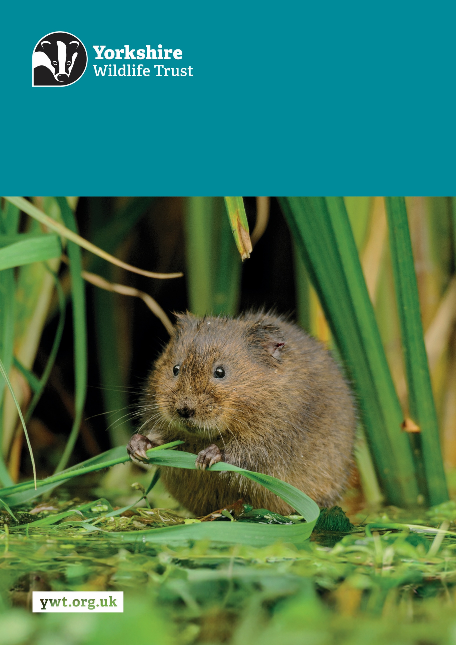
Z
Project Officer (North)
Job Description
About us

Yorkshire Wildlife Trust is one of the region’s largest environmental charities; our mission is to drive nature’s recovery in Yorkshire across our land and at sea.
We are one of 46 regional Wildlife Trusts working for nature and collectively forming the Wildlife Trusts, one of the largest collective national movements for wildlife in Europe.
Our vision is for wildlife and people thrive together across Yorkshire’s communities, land, rivers and sea. We work holistically in nature, thinking globally, planning at regional and landscape scale, while delivering our work in partnership with local communities, caring for local wildlife together. Our dedicated team of staff (c.190) and volunteers (c.1000) work together, on behalf of all our members (c.41,000), in every corner of Yorkshire to make this vision a reality.

Since forming in 1946 with our first reserve at Askham Bog, we now steward 115 nature reserves, which cover more than 3000 hectares of land and include some of our most precious wildlife. We also work extensively with other land managers, communities and businesses, to inspire, advise and deliver restoration work, supporting others too play their part in nature’s recovery.

We are passionate advocates for Yorkshire’s incredible wildlife and wild places. Join us and help create a diverse and inclusive team, committed to driving change for Yorkshire’s wildlife, communities and a positive future.

Job Description
Project Officer (North)
Responsible for: Project Assistant (North), volunteers and voluntary placements
Responsible to: Projects Manager (North)
Location/based at: York or Pickering, with travel across the region
Date last updated: 9th October 2025
Main Purpose of the Role
The North Project team undertakes the following streams of work:
- Landscape and catchment-scale habitat restoration and creation, particularly:
- river restoration to improve habitat for fish, invertebrates, reduce agricultural run-off and areas of unnatural erosion and sediment.
- wetlands for waders and plant communities
- ponds for Great Crested Newts and ark sites for White-Clawed Crayfish
- invasive species control
- reintroduction of rare wetland plant species into the landscape.
- Surveying and monitoring of habitats and species to identify issues, plan remedial work and measure the impact of any interventions.
- Stakeholder engagement to encourage landowners and land managers to take action for nature’s recovery by advising them on how to benefit from the projects we are delivering or via other funding opportunities (e.g. agri-environment schemes).
As Project Officer, you will:
- Help deliver our landscape and species recovery projects across the North Yorkshire area safely, on time, within budget and to a high standard.
- Work with the staff team to deliver practical tasks and survey field work, in addition to liaising with volunteers, stakeholders and contractors.
- Be flexible in your approach and able to assist on different projects according to where funding has been secured.
- Be closely supported and mentored by the Projects Manager and our partners.
Tasks and responsibilities
- Engage with landowners, land managers and contractors to deliver practical interventions.
- Conduct on the ground surveys and monitoring.
- Produce reports with recommendations for improvements and investment.
- Engage with staff, landowners, partners, and volunteers in a positive proactive manner.
- Support the coordination of volunteers by providing training and assigning relevant tasks.
- Deliver any scheduled events and activities which raise awareness and understanding of the value of the project to relevant stakeholders.
- Undertake record keeping of interventions and surveys, some input into the projects GIS mapping.
- Cultivate relationship with project funders and partners, ensuring excellent communication is provided via regular updates, in addition to the production and submission of project claims and reports.
- Engage with key stakeholders and attend (or lead, where appropriate) regular meetings.
- Manage delegated projects and project budgets, ensuring effective use of resources.
- Create the foundation for further projects and action to tackle the issues identified and actively work to secure additional funding to deliver these actions and interventions. This will include investigating funding outside of environmental stewardship options which could be secured to implement identified on-farm measures.
Other
- Promote the Trust and partner organisations whenever possible.
- Demonstrate our Trust values every day behaving with courage, respect, and integrity whilst trusting others and taking responsibility for your actions at all times.
- Support and promote the Trust’s commitment to equality, diversity and inclusion.
- The Trust is committed to safeguarding and promoting the welfare of children, young people, and adults at risk and expects all staff and volunteers to share this commitment.
- Abide by all Trust policies.
- Undertake any other duties as requested by your line manager and in line with the post.

Person Specification
Experience | Essential/Desirable
Strong background in working with farmers and landowners on land management schemes | Essential
Experience in delivering river restoration projects to improve water quality and create habitat for wildlife | Essential
Significant project management and development experience | Essential
Proven experience of managing and /or working with volunteers | Essential
Competent and experienced in engaging local communities | Essential
Experience of successfully working with a wide range of partners | Desirable
GIS and online mapping experience | Desirable
Sedimentation survey and mapping experience | Desirable
Experience in managing contractors and capital works | Desirable
Experience of gaining consents/permissions for practical works | Desirable
Knowledge and Skills | Essential/Desirable
Good knowledge and understanding of how to accurately and safely collect, process, and maintain data in line with organisational policy | Essential
Skilled at meeting funder needs through maintaining regular contact and building effective relationships | Essential
Highly competent in use of Microsoft Office / Windows-based computing, including Excel, Word, Outlook etc. | Essential
Ability to prioritise and organise work and consistently deliver project activities to time, cost and quality standards | Essential
Excellent oral and written communication skills | Essential
Able to build and develop relationships and work effectively and mindfully across teams of internal and external stakeholders to deliver shared objectives | Essential
A good understanding of health and safety, in particular writing risk assessments, giving tool talks, and safe management of survey tasks | Desirable
Good basic grasp of natural history with passion to develop knowledge | Desirable
Interested in an area of ecology and survey/monitoring experience | Desirable
An ability to interrogate data and extract and make use of relevant information from multiple sources | Desirable
Personal Qualities | Essential/Desirable
Natural communicator with a positive and enthusiastic approach | Essential
Self-motivated – able to work with independence, intelligence, drive and initiative | Essential
Ability to work as part of a team, and lead a team | Essential
Good time management skills and ability to forward plan. | Essential
Flexible enough to take on the ideas of other people and adapt ideas and way of working to meet the needs of others | Essential
Ability to undertake physical tasks for prolonged periods and in challenging environments. | Essential
Positive, can-do attitude, willing to tackle difficult problems. | Essential
Seeks out staff/partner knowledge and is prepared to share own expertise and knowledge | Essential
Essential Qualifications/Requirements | Essential
Willing and able to travel regularly to our remote sites across North Yorkshire | Essential
Full UK Driving Licence | Essential

Terms and Conditions
Salary: | £27,697-30,811 per annum (pro rata if part-time).
Hours: | 35 hours per week, Monday to Friday.  The nature of the post’s duties may occasionally require evening and/or weekend work.  Paid overtime is not available, but time off in lieu will be given for essential additional hours worked.
Contract: | 3-year contract from 1st January 2026 – 31st March 2029. A probationary period of 6 months applies to new staff, during which you must complete all essential, mandatory training.
Flexibility: | Whilst ensuring the needs of the business and the role are met, the Trust endeavours to meet the flexible working needs of its employees. Depending on the nature of the role, the Trust offers hybrid working (a mix of office and at home).
Holidays: | 30 days per annum inclusive of 3 office/site closure days over the Christmas period, in addition to national public holidays, rising to 33 days after 5 years’ service. All leave is pro rata for part time employees.
Pensions: | You may be eligible to be auto enrolled into the Trust’s Pension Scheme. Terms of the scheme are available on request from Finance.
Employee Assistance Programme: | The Trust provides an Employee Assistance Programme. This is a confidential service which aims to provide staff with support for a range of issues.
Health Questionnaire: | You will be asked to complete a health questionnaire in order to identify and support or adjustments you may require.
Equal Opportunities: | Yorkshire Wildlife Trust is committed to equal opportunities and appoints on merit. We welcome applicants from all sections of society regardless of gender, sexual orientation, race, disability, marital status, age and religion, perceived community background or political beliefs.
Place of Work: | The post will be based at the York head office: 1 St Georges Place, YO24 1GN or Ropery House, Pickering, YO18 8DY
Travel: | Public transport is encouraged although pool vehicles are available. In exceptional circumstances the use of the employee’s own vehicle may be necessary for business use, at a mileage rate of 45p per mile.
Training & Professional Memberships: | The Trust is fully committed to personal development and training and supports achieving and maintaining professional memberships and accreditations, with any essential-to-role professional memberships paid for by the Trust.

