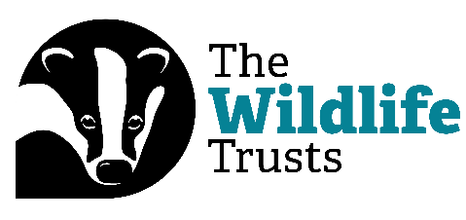
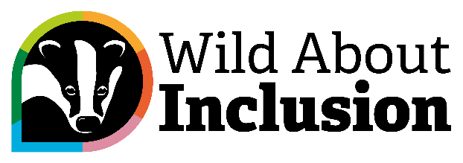

Digital Bitesize: Neurodiversity in Digital

Hi everyone, and welcome to another Digital Bitesize Video, brought to you by The Wildlife Trusts and Catalyst.
My name is Rob Gordon, and in this video, I’m going to talk to you about the importance of keeping neurodiversity in mind when it comes to digital accessibility. I’ll have to cover this topic in just sixty seconds. Are you ready? Then let’s go!
We as human beings are neurodiverse – which means our brains all work differently! So we need to design the things we create with neurodiversity in mind.
Remember best practice for digital accessibility – for example making sure you meet Web Content Accessibility Guidelines - WCAG. It’s important for neurodivergent people too.
Make sure you’re thinking about what visual and auditory components are like. Avoid loud background audio, flashing images or videos, and vibrant animations. Also bear in mind things like contrast and colour with your images and text when it comes to sensory sensitivity and comprehension.
Make things clear for users. Keep your locations and structure standard, use iconography that can help people understand what they need to do, and ensure that processes don’t rely on memory.
Think about your text too. Use a Sans Serif font, write in easy to understand language and explain abbreviations. Keep things consistent, concise, and clear.
Finally, do bear in mind that COGA - the Cognitive Accessibility Guidance that runs with WCAG – is there for any queries.
So, that’s that! Join us again for another Digital Bitesize video.

