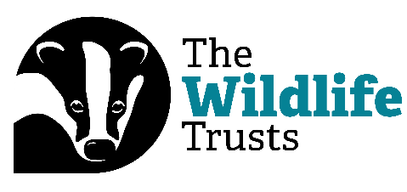
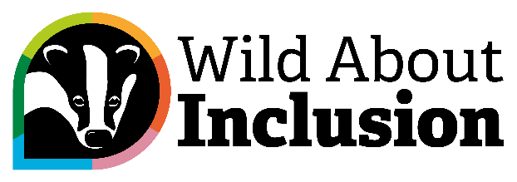

Digital Bitesize: Introduction to Digital Inclusion

Hi everyone, and welcome to our Digital Bitesize Videos, brought to you by The Wildlife Trusts and Catalyst.
My name is Rob Gordon, and in this video, I’m going to talk you through an introduction to digital inclusion with some top tips. For these digital bitesize videos, I’ll have to cover a topic in just sixty seconds. Are you ready? Then let’s go!
Always think about what the user needs are. Work with an open and democratic approach, thinking about different user needs rather than just the needs of the people creating something in a digital space. And where possible, speak to these users directly!
Remember, too, about the digital divide. Don’t assume that people know the ins and outs of digital tools or applications. Instead, make sure that guidance is given in plain language in how to use or access the things we create.
Speaking of plain language, make sure we’re writing in Plain English principles. This means writing with short sentences, in a way that is easy for people to understand, rather than using overly-complex language, acronyms and jargon.
Remember function over form at all times. Having something that looks swish, but that doesn’t work with a screen reader, or doesn’t properly communicate what button to press, will not be accessible or inclusive.
And finally, follow best practice. Keep up to date with tools like WCAG and the A11y Project to help make digital inclusion an everyday part of what you do.
And there we go! Join us again soon for another Digital Bitesize video.

