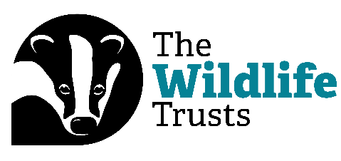
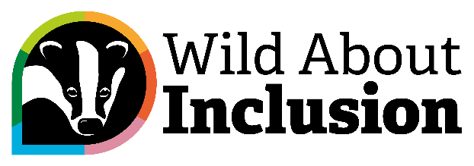

Digital Bitesize: Inclusion for Visual Impairment in Nature

Hi everyone, and welcome to another Digital Bitesize Video, brought to you by The Wildlife Trusts and Catalyst.
My name is Rob Gordon, and in this video, I’m going to talk to you about what inclusion and accessibility looks like for visual impairment in natural spaces, with digital tools and digital options in mind. I’ll have to cover this topic in just sixty seconds. Are you ready? Then let’s go!
‘Know before you go’ is extremely important here. Make sure there is clear and easy to find accessible information ahead of time. What are the facilities, where are the toilets, is there a visitor centre, what does transport look like? Context is king. You could add key information in the same place for what to expect to find in terms of species
This is important: make it all downloadable! Especially if you know that your location is spotty with phone signal.
On site, think about what would be useful to have. When descriptions are noted, what about QR codes that take someone through to a screen reader compatible version. And remember tactile options! Not digital, but extremely important.
If it’s a suitable site, also think about having speakers for key pieces of information.
Finally, do remember to think about what function looks like at your site. Remember that physical tools are so important – that means Braille and tactile wayfinding maps, clear paths, high contrast signage, and more. Accessibility is diverse, so remember to make non-digital accessibility a key focus too. Especially if you are somewhere with little connectivity.
So, that’s that! Join us again for another Digital Bitesize video.

