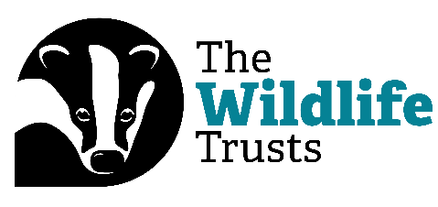

Digital Bitesize: Empowering Staff Networks

Hi everyone, and welcome to our Digital Bitesize Videos, brought to you by The Wildlife Trusts and Catalyst.
My name is Rob Gordon, and I’m going to talk to you about staff networks, and how the digital model can help these vital tools of inclusion in the workplace thrive. For these videos, I have to cover this topic within sixty seconds. Are you ready? Then let’s go!
Staff networks are a great way for people with similar backgrounds or experiences to meet, network, and thrive in a workplace. But sometimes this can be a challenge – especially if you’re at an organisation that is geographically spread out.
This is where digital options can come in. Online meeting tools like Zoom or Teams can make sure that those who are distant geographically can still have their voice heard, and still enjoy the benefit of meeting people across the group. This can even grow into things like out of work WhatsApp groups, so people can get to know each other better.
Digital tools can be great for organising. A living document terms of reference for a staff network can shift to suit the group’s needs, while apps like Mentimeter and Google Jamboard can help with planning and developing plans of action.
And finally, make use of whatever options you have! Is there an intranet or SharePoint that your organisation uses? If so, they are great places to host and create all kinds of diverse content and materials to further inclusion, wherever you are.
So there we have it – even if you’re not close geographically, there are still incredible options to make staff networks a reality! And, join us again soon for another Digital Bitesize video.

