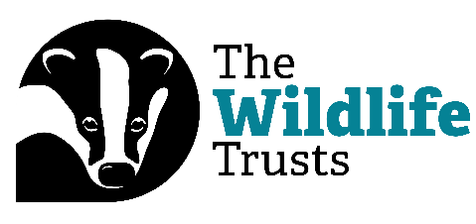
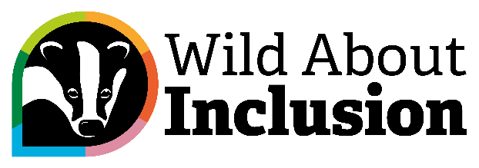

Digital Bitesize: Digital Inclusion and Democratising Work

Hi everyone, and welcome to our Digital Bitesize Videos, brought to you by The Wildlife Trusts and Catalyst.
My name is Rob Gordon, and in this video, I’m going to talk to you about why digital inclusion is a real benefit when it comes to democratising work. I’ll have to cover this topic in just sixty seconds. Are you ready? Then let’s go!
Work is often defined by the things we can’t do. But some digital tools can help democratise our workplaces and make them more inclusive.
Take remote working. If the pandemic has taught us anything, it’s that we can work in far more inclusive ways than we thought. It’s not always possible, but for many roles we could be based anywhere - and possibly be more effective than when having to travel to a location!
This means things like Teams and Zoom, but other tools, too. Miro boards are great collaborative tools, Menti slides can gather feedback quickly and anonymously, and SharePoint, Office shared documents, and Jamboard provides lots of flexibility.
Think about the positives that inclusive recruitment practices can bring. Hiding personal information in applications and providing more open approaches to interviews with digital tools can make a big difference.
Through this approach we can give more flexibility for disabled people at work. We challenge geographical inequality, no longer stuck in one city or town for arbitrary reasons. And digital work options can help with carers, too!
In short, it gives people autonomy to do their jobs in a way that works for everyone.
So there we are! Join us again soon for another Digital Bitesize video.

